1. QUEN OTITLATUILTIC C) QUEN OTICEMILHUITIC
2. QUEN OTITEOTLAQUILIC D)QUEN OTIYOHUALILIC

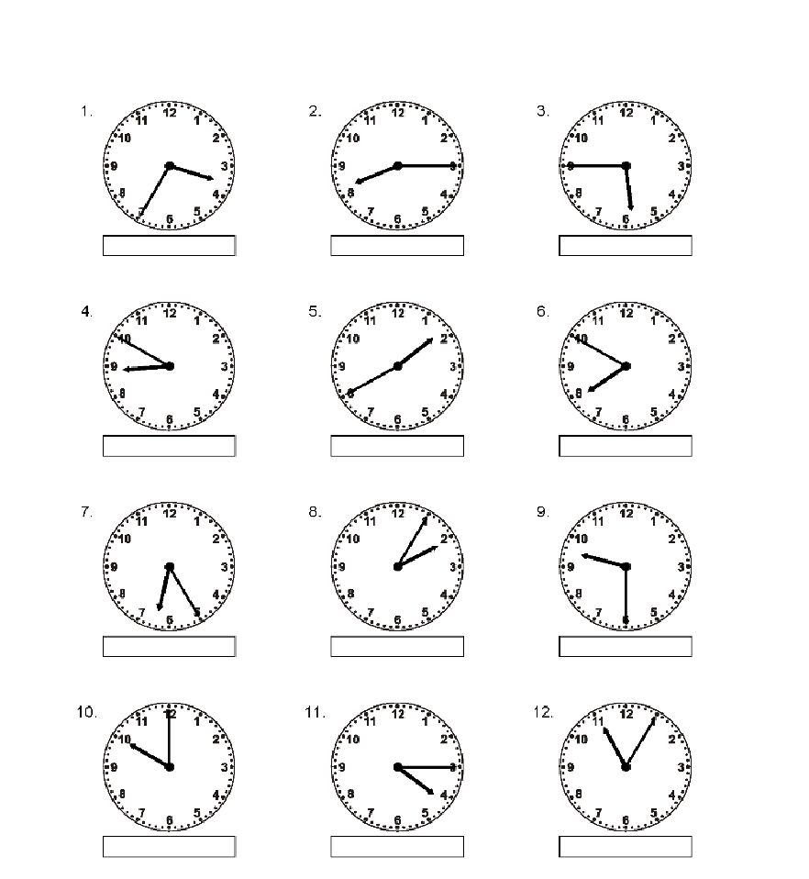

P.M. A.M A.M.

A.M. P.M P.M..

P.M. A.M P.M..

A.M. A.M P.M..

A B C D A B C D A B C D

A B C D A B C D A B C D

A B C D A B C D A B C D

A B C **D** A B C D A B C D